|  |  |  |
| --- | --- | --- |
| **Outcome in terms of Product Development** | **IPR Current Status** | **Socially and Economically Relevance** |
| * To help the farmers in bringing efficiency in the process of pesticide spraying process while minimizing health issue due to the chemicals.. * To develop the spraying mechanism in agriculture sector with less use of pesticides and fertilizers. * To detect the sapling and canopy automatically. | * In process * Enroll under SANDIP TBI in Pre-incubation Segment | * To help Farmers by easing an essential task. * To maintain fertility of the soil by giving just the right amount of pesticides. * To develop Agridrone sprayer which use less fertilizers and pesticides that saved financial capital. * To use the open source technology helps in increasing technology access. |

Developed By:

|  |  |  |  |
| --- | --- | --- | --- |
| **Young Innovators** | | **Mentor** | |
| **Student SF ID** | **Names** | **Staff SF ID** | **Names** |
| 112018275 | ABHISHEK ASHOK PATIL | 1035 1097 | Dr. Omkar S. Vaidya  Dr. Gayatri M. Phade |
| 112018112 | SUDHIR BHAUSAHEB PAWAR |
| 112018384 | ASIT SANJEEV BHATE |

Achivements:

|  |
| --- |
| Participated in National Level Competitions of Prototypes Development TECHNOVA-TION 2021 organized by Dr. B R Ambedkar National Institute Of Technology (NIT), Jalandhar and Innovation Club on 6-7 March, 2021. |

**Development Stage**

**Development Stage**

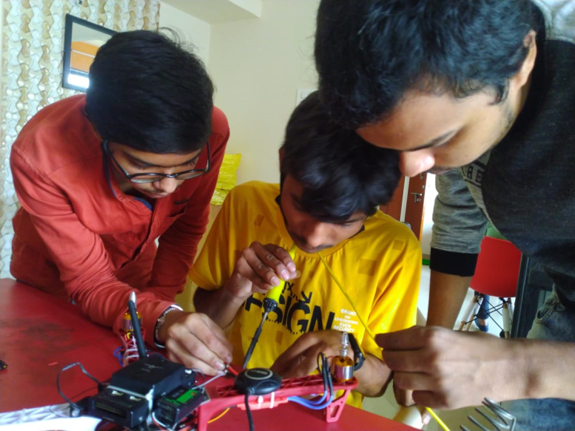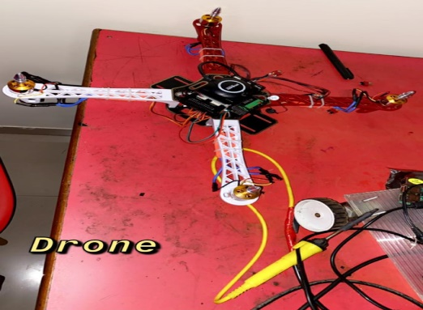

**Testing and Troubleshooting**

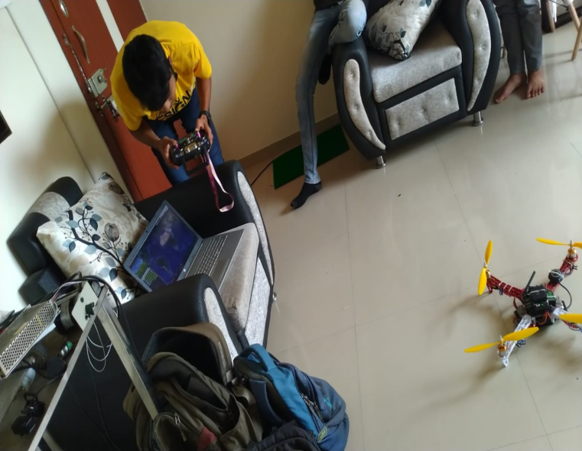

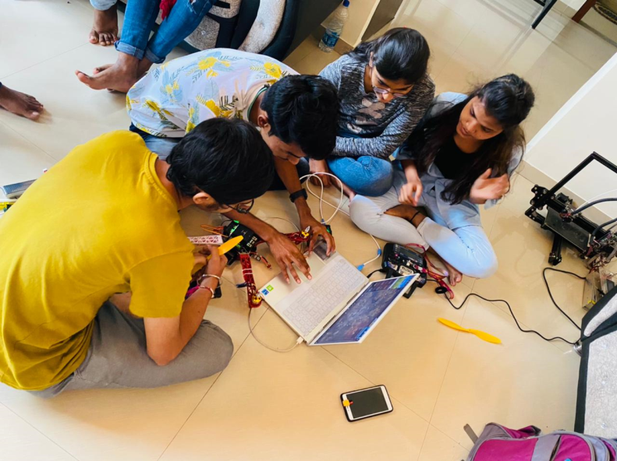

**Final Flying Stage**

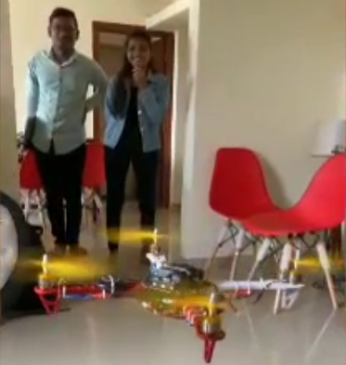

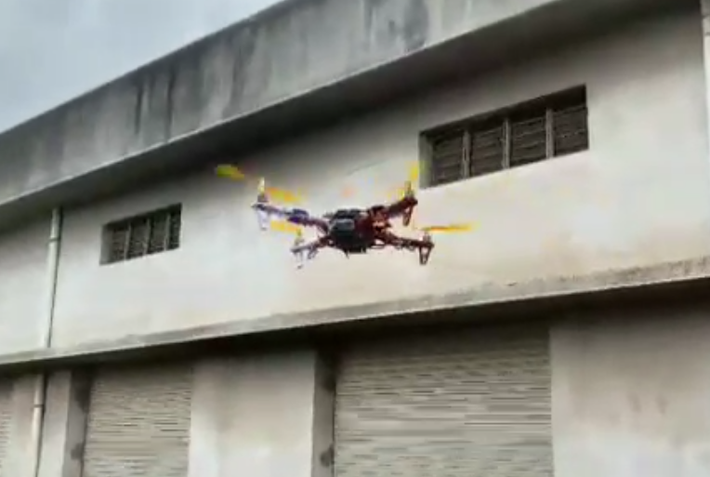

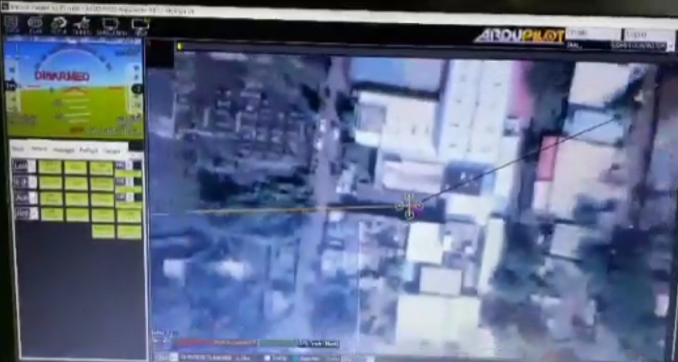

**GPS Tracking of Drones using ArduPilot**